|  |
| --- |
|  |
| Design document |
|  |
| MDW – Ludo game |

**Fontys univeristy of applied scieences**

June 26, 2016

Authored by: Monica Stoica, Dimitar Vikentiev, Rosen Danev

Table of Contents

Architecture diagram 2

Description of Interfaces 3

IGame: 3

IGameCallback: 4

IAccount: 4

Class Diagram 6

Database 10

Appendix A - Sequence Diagrams

# Architecture diagram

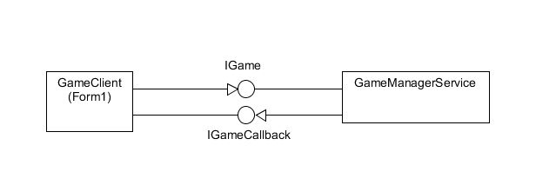

# Description of Interfaces

# IGame:

All the methods in the class are of type [OperationContract]

List<Player> Connect(string username, int nbOfPoints, int Position, int priority);  
 This method will be called each time when a person enters the game and that user will be connected. His/her information, such as username, will be shown in a certain list box in the main form.

void Disconnect();  
 This method one will be used when a player exists the game and the he/she will be disconnected. The player will also be removed from the list box and the other players will be informed.

void CreatePlayer(string username, int nbOfPoints, int position, int priority);

List<Player> GetPlayers();  
 It will return a string with all information of a certain player depending on his/her username.

string GetPlayerInfo(string playerName);

int ThrowDice();  
 Will return a random integer from 1 to 6.

void MoveForward(Pawn p, int newPosition);  
 When this method is called the pawn will move forward according to the diceresult.

void SendMessage(string msg, string playerName);

Used for communication between players.

void GamePause(bool b);

Pauses/Resumes the game for all players.

void ResetPawn(Pawn p);

Respawns a pawn.

bool AllFinish(string playerName);

Checks if all the pawns of a player have finished.

void PawnHasFinish(Pawn pawn, string playerName);

Sets the final position of the pawn.

void NotifyForWinner(string playerName);

Notifies other players that there is a winner.

void setTurn();

Sets the turn of the player based on priority.

bool getTurn(string player, Pawn pawn);

Checks if the current player is allowed to make a move.

bool diceTurn(string player);

Checks if the current player is allowed to roll the die.

# IGameCallback:

void NewPlayerConnected(List<Player> players);  
 This method will inform other players when a new player is connected.

void MessageRecieved(string msg, string playerName);

Sends the message to all the players in the game.

void DiceNotify(int result);

Notifies other players about the dice result.

void PawnNotify(Pawn p, int newPosition);

Notifies the other players about the new position of the pawn.

void GamePaused(bool b);

Notifies the other players that the game has been paused/resumed.

voi d NewWinner(string username);  
The method will inform other players when some of them has finished and will show his/her place (ranking) among other players.

void RespawNotify(Pawn p);

Notifies the other players that the pawn has been respawned.

# IAccount:

string LogIn(string username, string password);

Checks if the combination of username and password matches.

bool createAccount(string name, string username, string password);

Checks if there is already a user with that name and if not, it creates a new database entry.

List<string> getRanking();

Returns a list of the players’ username and their points.

bool AwardWinner(string userName, int points);

Adds points to a player when winning the game.

List<string> getPlayers();

Returns a list with the username of the players.

# Class Diagram

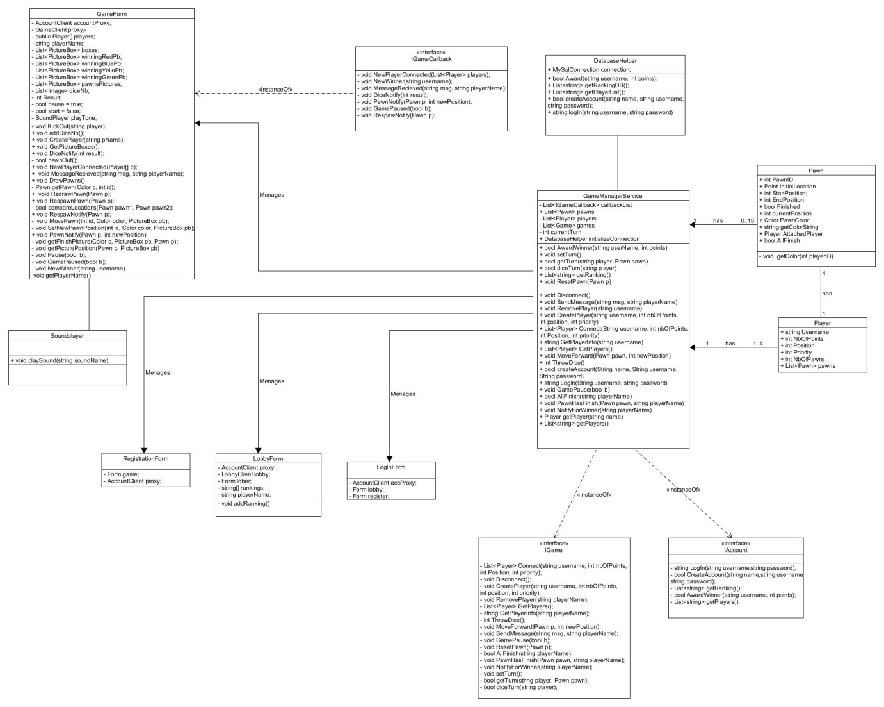

*Below, you can find a description of the fields, properties and methods used in our Class diagram.*

***Class Player***

*Properties:*

- Username: string – represents the name of the player

- NbOfPoint: int – represents the number of points accumulated by a player

- Position: int – represents the position of the player compared to other players

- Priority: int – represents the priority of the player when starting a new game (e.g. who will roll the die first)

- NbOfPawns: int – represents the number of pawns the player needs to bring to the finish line in order to win

- PawnColor: int – represents the colour of the pawns of a player

- Pawns : List<Pawn> - stores all the pawns of a player

*Constructor:*

* Player(string username, int points, int position, int priority, Color color)

***Class Pawn***

*Properties:*

* PawnID: int – the unique identification of a pawn
* Status: status – the current status of a pawn
* PawnImage: Image – the representative image of a pawn
* StartPosition: int – the starting position of the pawn
* EndPosition: int – the ending position of the pawn
* CurrentPosition: int – the current position of the pawn
* GetColorString: string – the color of the pawn
* AttachedPlayer: Player -the player to whom the pawn belongs to.

*Constructor:*

* Pawn(int ID);

*Methods:*

* getColor(int playerID): void – sets the color of the player

***Class GameManagerService***

*Properties:*

* Players: List<Player> - list of all players
* Callbacks: List<IGameCallBack> - list with all callbacks
* Pawns: List<Pawn> - list with all pawns
* Games: List<Game> – list with all games
* currentTurn: int – stores the current turn

*Methods:*

* AwardWinner(string userName, int points): bool – awards the winner with points.
* setTurn(): void – Sets the turn for players
* getTurn(string player, Pawn pawn): bool – check if the current player can move bases on priority. It also checks if the pawn is owned by the player.
* diceTurn (string player) :bool – check if the player is allowed to roll the die.
* getRanking(): List<string> - list of all player’s ranking from the database.
* ResetPawn (Pawn p): void – resets the pawn to its initial position.
* CreatePlayer (string username, int nbOfPoints,

int position, int priority): void – add a new player to the list.

* RemovePlayer (string username): void – removes player from the list.
* Connect (String username, int nbOfPoints,

int Position, int priority): List<Player> - connects a new user.

* Disconnect: void – disconnects a player.
* SendMessage (string msg, string playerName): void – sends a message to other players.
* GetPlayerInfo (string username): string – returns information about a player.
* GetPlayers(): List<Player> - list of all connected players.
* MoveForward (Pawn pawn, int newPosition): void – Notifies other player that a pawn has moved.
* ThrowDice: int – generates a random number between 1 and 6.
* LogIn (String username, string password): string – logs in a user.
* createAccount (String name, String username,
* String password): bool – registers a new user.
* GamePaused (bool b) : void – Pauses the game for all users.
* AllFinish (string playerName): bool – checks if all the pawns of a player have reached the final
* PawnHasFinish (Pawn pawn, string playerName) : void – checks if a pawn has finished.
* NotifyForWinner (string playerName): void – notifies other players that there is a new winner.
* getPlayer (string name): Player – returns a player.
* List<string> getPlayers() – returns a list of players

***Class DatabaseHelper***

*Properties:*

* Connection: MySQLConnection – initializes database connection.

*Methods:*

* Award (string username, int points): bool – gives award points to a given player into the database.
* getRankingDB(): List<string> - gets the ranking of the players and puts them in a list
* getPlayerList(): List<string> - gets the players from the database and puts them in a list.
* createAccount (string name, string username,

string password): bool – registers a player into the database.

* logIn (string username, string password): string – checks if the given username and password exists in the database.

***Class Soundplayer***

*Methods:*

* PlaySound(string SoundName): void – plays a sound

***Class GameForm***

*Fields:*

* AccountClient accountProxy
* GameClient proxy
* Player[] players
* string playerName
* List<PictureBox> boxes – list with all pictureboxes that represent the board
* List<PictureBox> winningRedPb
* List<PictureBox> winningBluePb
* List<PictureBox> winningYelloPb
* List<PictureBox> winningGreenPb
* List<PictureBox> pawnsPictures
* List<Image> diceNb
* int Result
* bool pause = true
* bool start = false
* SoundPlayer playTone

*Methods:*

* void KickOut(string player) – checks if there are already four players in the game. If yes, the current player is not allowed to join.
* void addDiceNb() – adds the pictures for the dice according to the number rolled.
* void CreatePlayer(string pName) – creates a new player.
* void GetPictureBoxes() – adds all the pictureboxes to the lists.
* bool pawnOut() – respawns the pawn
* void DrawPawns() – draws the pictures of the pawns for each player
* Pawn getPawn(Color c, int id) – returns a pawn based on its colour and id
* void RedrawPawn(Pawn p) – redraws the pawn on the screen
* void RespawnPawn(Pawn p) – respawns the pawn
* bool compareLocations(Pawn pawn1, Pawn pawn2);
* void RespawNotify(Pawn p) – respawns the pawn
* void MovePawn(int id, Color color, PictureBox pb) – move the pawn
* void SetNewPawnPosition(int id, Color color, PictureBox pb) – sets the new position of the pawn
* void getFinishPicture(Color c, PictureBox pb, Pawn p);
* void getPicturePosition(Pawn p, PictureBox pb)
* void Pause(bool b) – pauses the game by disabling the functionality.
* void getPlayerName() – returns the name of the player.

***Class LoginForm***

*Fields:*

* AccountClient accProxy;
* Form lobby;
* Form register;

***Class LobbyForm:***

*Fields:*

* AccountClient proxy;
* LobbyClient lobby;
* Form lober;
* string[] rankings;
* string playerName;

*Methods:*

* - void addRanking() - adds the ranking from the database to a local list.

***RegistrationForm***

*Fields:*

* Form game;
* AccountClient proxy*;*

# Database

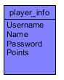

The diagram represents the database design which will be used in order to implement the Sign in, Log in and Ranking functionalities. The entity, stores the information about a user such as username(string), password (string), Name (string) and the points (int). The primary key is username since there cannot be two players with the same username.